UNITED FITNESS STUDIO CLASS DESCRIPTIONS

 | Group Active: Activate Your Life in only one hour! Feeling fitter, stronger and more alive has never been more achievable or more enjoyable! Incorporating all elements of fitness, Group Active will increase your cardio fitness, build your strength and improve your balance and flexibility. All in a supportive group environment, with motivating music and caring instructors. Get more out of life, Get Active.
 | Group Power: Group Power is Your Hour of Power! This 60-minute barbell program strengthens all your major muscles in an inspiring, motivating group environment with fantastic music and awesome instructors. With simple, athletic movements such as squats, lunges, presses and curls, Group Power is for all ages and fitness levels. Discover results, discover Group Power!
 | Group Ride: Everyone Finishes First in group Ride! Pedal in groups, roll over hills, chase the pack, climb mountains and spin your way to burning calories and strengthening your lower body. This 60-minute cycling program is geared for anyone that can ride a bike. Motivating music, awesome instructors and an inspiring group environment lets you Ride On!
 | Circuit: If you are looking for a high intensity workout that will help shape and tone your body, then look no further. Circuits are a great way to incorporate weight with high intensity intervals. A full body workout is achieved, isolating individual muscle groups
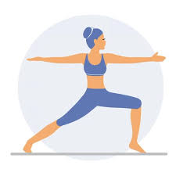 | Yogalates: Will grow you longer and stronger with an invigorating 60-minute mind-body workout. It incorporates Yoga and Pilates fundamentals with athletic training for balance, mobility, flexibility and the core. Emotive muscade drives the experience as you breathe and sweat through this full-body fitness journey.
 | Cardio Boxing: Is an intense boxing-based class that uses high intensity interval training. You will give all your effort through quick, intense bursts of mixed cardio drills, punching combinations and bodyweight exercises followed by short recovery periods. This will burn more fat in less time by keeping your heart rate up.
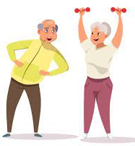 | Seniors: Our Seniors class incorporates a combination of strength training and basic movements to improve flexibility, balance and mobility. The class is designed for those that prefer to workout without the added impact to joints. A portion of the class includes aerobic movements.

